Low-distortion sine wave oscillator
Robert-Ștefan PETCU

October 2025
Contents
Abstract 3
Literature 4
Analysis 10
Approach 13
Performance 13
Conclusions 19

Abstract
I have designed and built a 15 V-powered oscillator that generates a 10 kHz ±0.1% sine wave with a spurious-free dynamic range (SFDR) exceeding 50 dB. The output amplitude is adjustable from 0 V to 5 V peak-to-peak using a screwdriver-controlled potentiometer. The circuit employs a quadrature architecture, followed by a diode clipping stage and an active band-pass filter. The final potentiometer, part of a voltage divider, allows precise control of the output amplitude. The inclusion of the band-pass filter effectively minimizes distortion by attenuating unwanted frequency components. Before implementation, the circuit was thoroughly tested in Multisim, where Fourier analysis indicated an SFDR greater than 110 dB. However, during physical implementation, it became evident that component tolerances play a much more significant role than expected, considerably degrading the quality of the sine wave output. As a result, the practical performance was notably worse than the simulation results. The circuit was physically realized on a breadboard using through-hole components, including NE5532P operational amplifiers, 1N4148 diodes, standard THD resistors, capacitors, and potentiometers. Fine tuning of the potentiometers was performed to achieve the desired oscillation frequency tolerance and optimize the SFDR. All measurements were carried out using conventional oscilloscopes and multimeters.

Literature
The architecture I proposed for building this oscillator is the quadrature, which I found simple to implement, since it contains only two op-amps, but still gives little distortion output.[1] Before this decision, the Wien Bridge Oscillator was more attractive to me, mainly because of its better simulation results and even easier implementation. However, the Wien Bridge is more dependent on the real values of the resistances and capacitances, thus making it harder to adjust in order to reach the desired results.[2] Other architectures, like the Bubba oscillator, were avoided because of the larger amount of components used, thus requiring more than one breadboard to implement.[1] The Colpitts oscillator offers great stability at high frequency, which is not intended for this assignment, so I did not consider using it. The Hartley oscillator is suited for low frequency applications, but it doesn’t have that good of a stability. More than that, LC oscillators require inductors, which are to be avoided because of their size. [3]

References:
[1]: Sedra, Adel S. and Smith, Kenneth C., Microelectronic Circuits, [8th Edition], Oxford University Press, 2019.
[2]: Horowitz, Paul and Hill, Winfield, The Art of Electronics, Cambridge University Press, 2015
[3]: Georgi Radulov, Aida Todri-Sanial, Lecture 4.1: LC oscillators for Electronic circuits 2, Technical University of Eindhoven, 2025

Architecture
The main and most important part of the oscillator is, of course, the oscillator itself. I implemented a quadrature architecture, just like it was presented in the lecture.
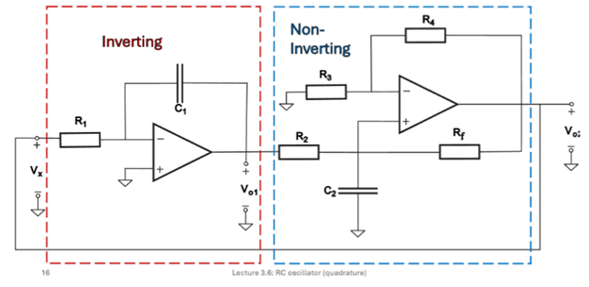
The oscillator's output amplitude was stabilized and controlled by a simple, practical diode clipping circuit, consisting of two diodes and four resistors. The primary objective of this segment was to clip the voltage as smoothly as possible to maintain a constant output and minimize the distortion. While superior methods were considered, like a JFET-based Automatic Gain Control or a light bulb limiter, these were ultimately rejected because the necessary specialized components were difficult to source, leading to the selection of the readily available and compact diode clipper as the most feasible solution.
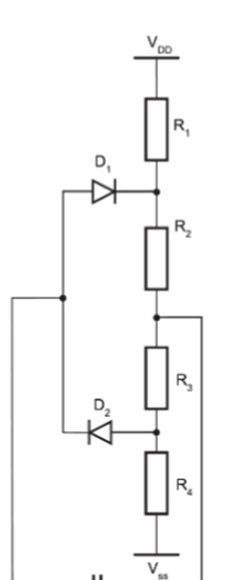
diode clipper part

At the output of the oscillator, I designed an active bandpass filter, so that the unwanted frequencies would be filtered out. I chose an active bandpass filter, and not a passive one, because it provides voltage gain, preventing the filter itself from attenuating the signal's desired amplitude. Furthermore, an active filter is offering a much sharper rolloff, allowing for better selectivity. I have also chosen exactly the same two resistors and the same two capacitors, so that in practice the Δf would be as small as possible, which means better selectivity.
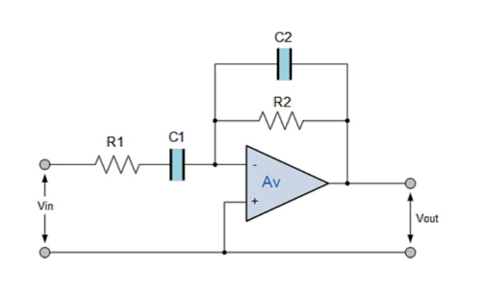
Active bandpass filter used
(source: https://electronics.stackexchange.com/questions/503267/design-an-active-bandpass-filter-to-get-1-5mhz-peak-frequency-and-300khz-bandLinks to an external site.)

The last stage of designing my circuit was to choose a voltage divider based on a potentiometer and a fixed resistor. The objective of this segment is to serve as the final amplitude control, allowing the user to adjust and precisely lower the voltage level of the clean sinusoidal output signal from the bandpass filter before it leaves the system. The use of a potentiometer provides a variable, user-adjustable attenuation, ensuring the output amplitude can be set to the desired operational level without affecting the signal's characteristics.

The proposed oscillator architecture features a strong balance between practicality and performance, with its key advantages coming from the choice of the Quadrature Oscillator core. This core provides good signal purity and is simple to implement, requiring only two op-amps, which facilitates easy prototyping. A significant highlight is the use of an active bandpass filter at the output, which is crucial for enhancing signal quality by aggressively removing harmonics generated by the limiter and providing isolation and gain to the signal. However, the design also carries notable disadvantages, primarily the reliance on a simple diode clipping circuit for amplitude control. This component introduces intrinsic distortion, necessitating the subsequent filter stage and compromising overall signal purity compared to ideal, but unavailable, JFET-based circuits. Furthermore, as an RC oscillator, the frequency is inherently less stable and more susceptible to drift. Another disadvantage is the sensitivity to resistor values. As a result, two potentiometers had to be used to adjust the circuit as fine as possible in order to obtain the right frequency.

The values of the components were calculated in the following way:
Initially, when there was no filter to reduce the amplitude, the resistors in the clipping circuit had the following values: R11=10k, R12=1.2k, R13=1.2k, R14=10k. These values worked just fine before applying the filter, but afterwards I realized that the amplitude was greatly diminished at the output of the filter. This is because the bandpass filter was attenuating considerably my signal. To counter this, i decided to reduce the clipping performed by the diodes. I changed the ratio between R11 and R12 from 8.33 to 5.89. The final values for the clipping resistors are: R11=330k, R12=56k, R13=27k, R14=56k. Why did I choose values so high? I realized that the less current flows through, the smaller the noise will be, so I implemented this small change in order to every so slightly reduce the noise.
Regarding the active passband filter, I have chosen the values R5=R6=15k and C3=C4=1nF. At first glance, this might seem like a bad choice, because the pass frequency would then be 10610Hz (theoretically).
But after measuring the values of the components with the multimeter I realized they are slightly above the written value.
The equations are f1=1/2*pi*sqrt(R1*C1)
f2=1/2*pi*sqrt(R2*C2)
BW = f2-f1
Thus, a slightly larger C and R would amount for a smaller f. In my case, the larger C and R made the real f be exactly 10kHZ, with a tolerance of 1%. This is a real example of why components shouldn’t be blindly trusted and always measured before using them.
Resistors with a value of 32k were constructed using a 27k resistor in series with a 5k resistor. All resistors, except for R1 and Rf, were sourced as single, readily available components, having been specifically chosen to meet their required resistance values. The same can be said about all the capacitors. In total 4 capacitors of 1nF were used, not requiring any need for grouping.
In order to fine adjust the feedback resistance, I replaced the Rf resistor from the output of the second op-amp with a potentiometer. I am aware this is not preferable, but very small changes, less than the 5% tolerance of the resistors, have a high impact on the noise of the sine, so I had to implement it this way. Another resistor that plays a huge role in adjusting the frequency is R1. This one also had to be replaced with a potentiometer so that fine adjustment was made possible. The last potentiometer used is solely for amplitude control. I genuinely tried to replace the potentiometers with resistors, but it was very impractical because of the high amount of resistors used in order to recreate the desired resistance of the potentiometer. The desired resistance of the potentiometers was hard to obtain by combining multiple resistors in series and parallel. Also, a less than ¼ of a degree of rotation of the screwdriver tuning the potentiometer, changed the noise and frequency drastically. As a result of this, fine adjustment was possible only with potentiometers and replacing them with a group of resistors turned out to be impossible. After this experience I learned how precise the circuit must be in order to obtain a constant very pure sinewave.

The placement of the components on the board was done adhering to the rules of the breadboard circuitry. Where possible, I made wires as short as possible and sticked to the board, in order to reduce parasitic resistances. Also, I have shortened the terminals of each component and placed it as low as I could. After all, being a prototype and not a final product amplifier some wires were intentionally let longer so that they could be disconnected in order to test the oscillator without certain stages.
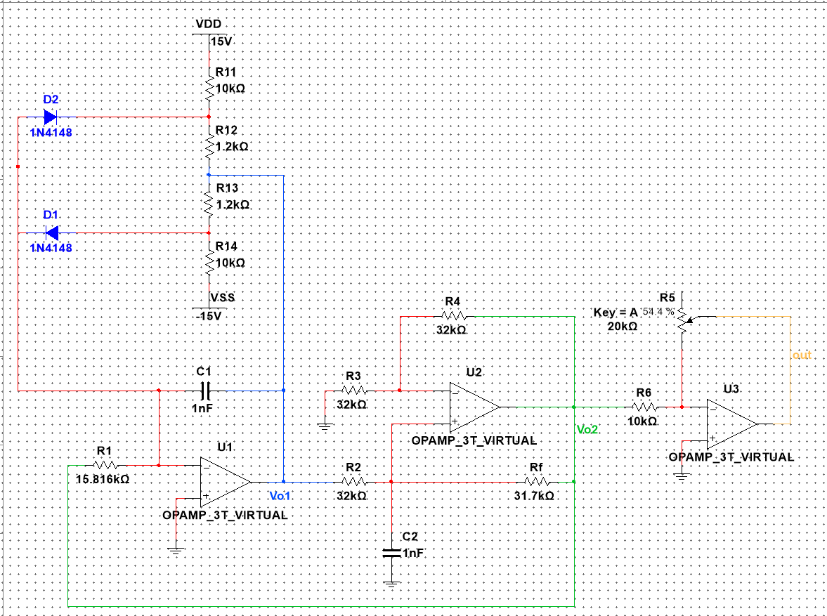
Initial design of the circuit, without an active bandpass filter, but with an active amplitude gain control unit.

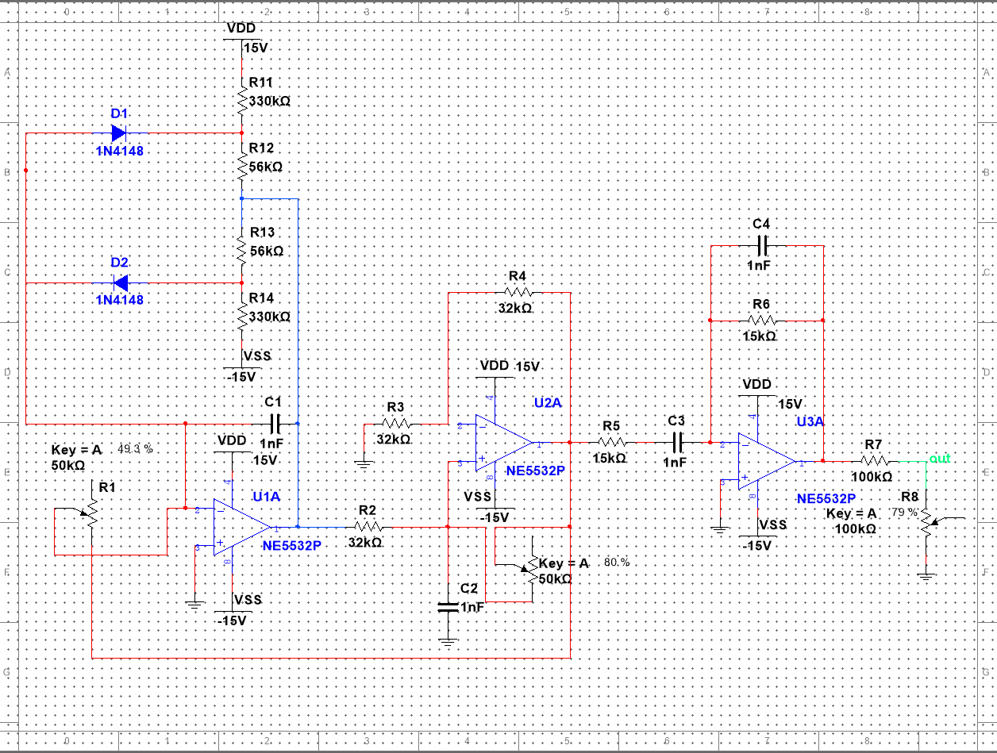
This is the final form of the architecture, after doing the following modifications from the initial design:
- Adding an active passband filter after the output from the quadrature.
- Using a voltage divider to control the amplitude at the output (with no gain)
- Replacing the resistors in clipping stage and output voltage divider stage with components with much larger resistances. As I previously stated, the smaller the current, the better the distorsion.

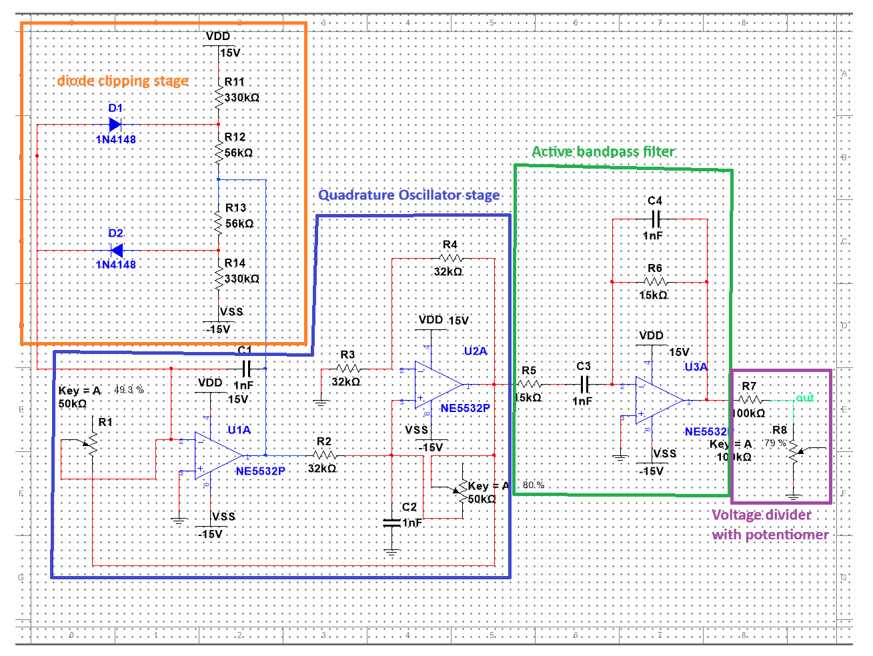
Block diagram scheme of the whole circuit

Now I present to you the physical implemention of the circuit on the breadboard.
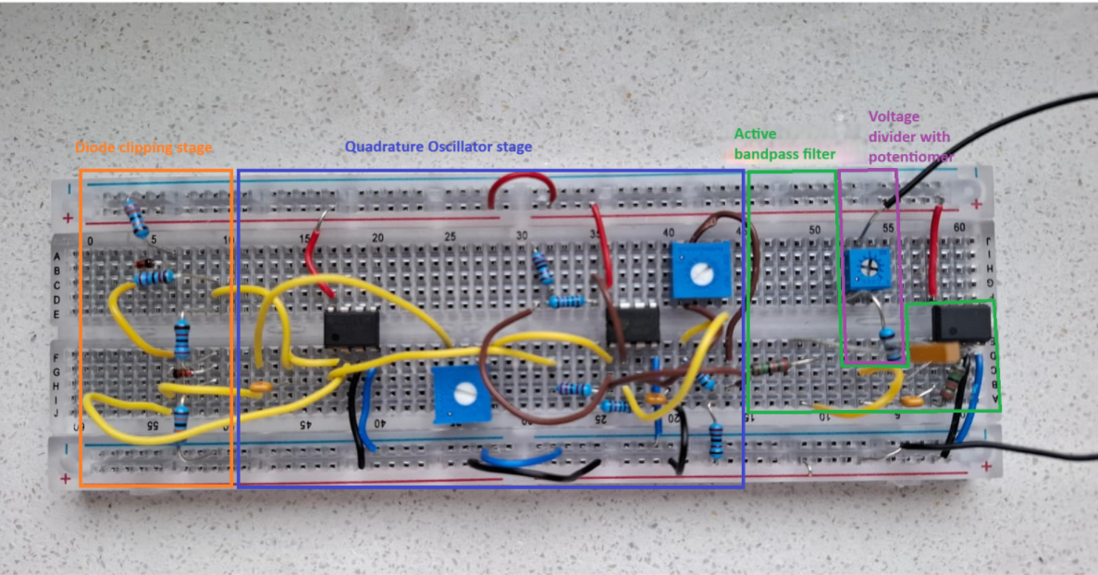

Analysis
The Quadrature oscillator circuit is composed of a non-inverting amplifier and a loop of two cascaded integrators. The principle of operation is that each integrator provides a 90 degrees phase shift, resulting in a 180 degrees phase shift after two integrators. The final 180 degrees of phase shift required by the Barkhausen criterion is supplied by the non-inverting amplifier and/or a sign change in the feedback loop.
After calculations, the following transfer function was obtained:
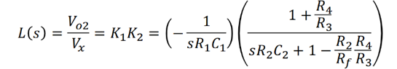
To further simplify, R3 was chosen = R4 and R2 = Rf.
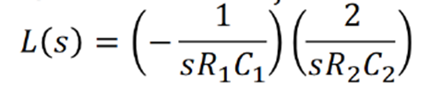
Now R1*C1=1/2*R2*C2

C1=C2 and 𝑅2=R3=R4= 2*R1

After all simplifications, L(s)=1/w2R₁²C2, thus w = 1/R1*C = 2pi*f
Since the desired frequency is 10kHz, R2= R1/2 was chosen 32k, formed from a 27k resistor in series with 5k resistor.
The value of C was chosen as 1nF.

The main equations that define the passband filter are f1=1/2*pi*sqrt(R1*C1) and f2=1/2*pi*sqrt(R2*C2). BW = f2-f1, so in order to have a thinner BW, we need f2 and f1 to be as close together as possible. To do this, two identical capacitors and two identical resistors were used.
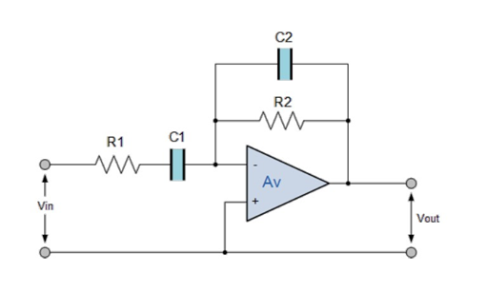

The voltage divider at the very end of the circuit works under the equation Vout = Vout_filter * R8/(R7+R8).
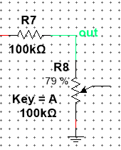
The many simulations conducted generally aligned with theoretical expectations. I observed changes, especially after I replaced in Multisim the virtual op-amp component with the NE5532P. After this replacement, the SFDR decreased, because the virtual op-amp was an ideal component, while the NE5532 simulated better the reality, thus the SFFR decreased dramatically from 112dB to 58dB.
Once I did the measurements in the lab, I obtained a SFDR of 53dB, which I remarked being close to the value obtained after simulating. A difference of 5dB from the simulation to the real-life measurement I find quite small.
The primary error mechanisms limiting real-world performance stem from non-ideal passive components, including the tolerances and parasitic inductance/capacitance of the resistors and capacitors, coupled with implementation losses introduced by board-level parasitics, signal routing (wires and breadboard) and the inherent non-linearities and limited slew rate of the physical op-amps themselves.

Below I present to you the Transient and Fourier analyses of the circuit in Multisim:
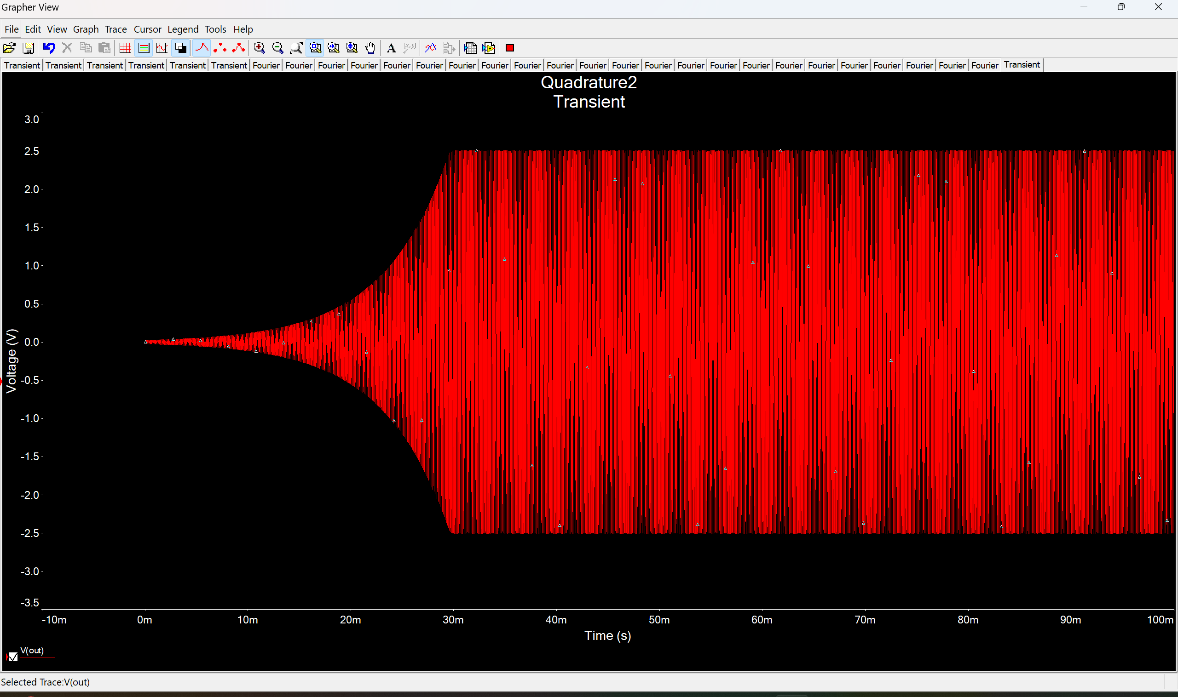
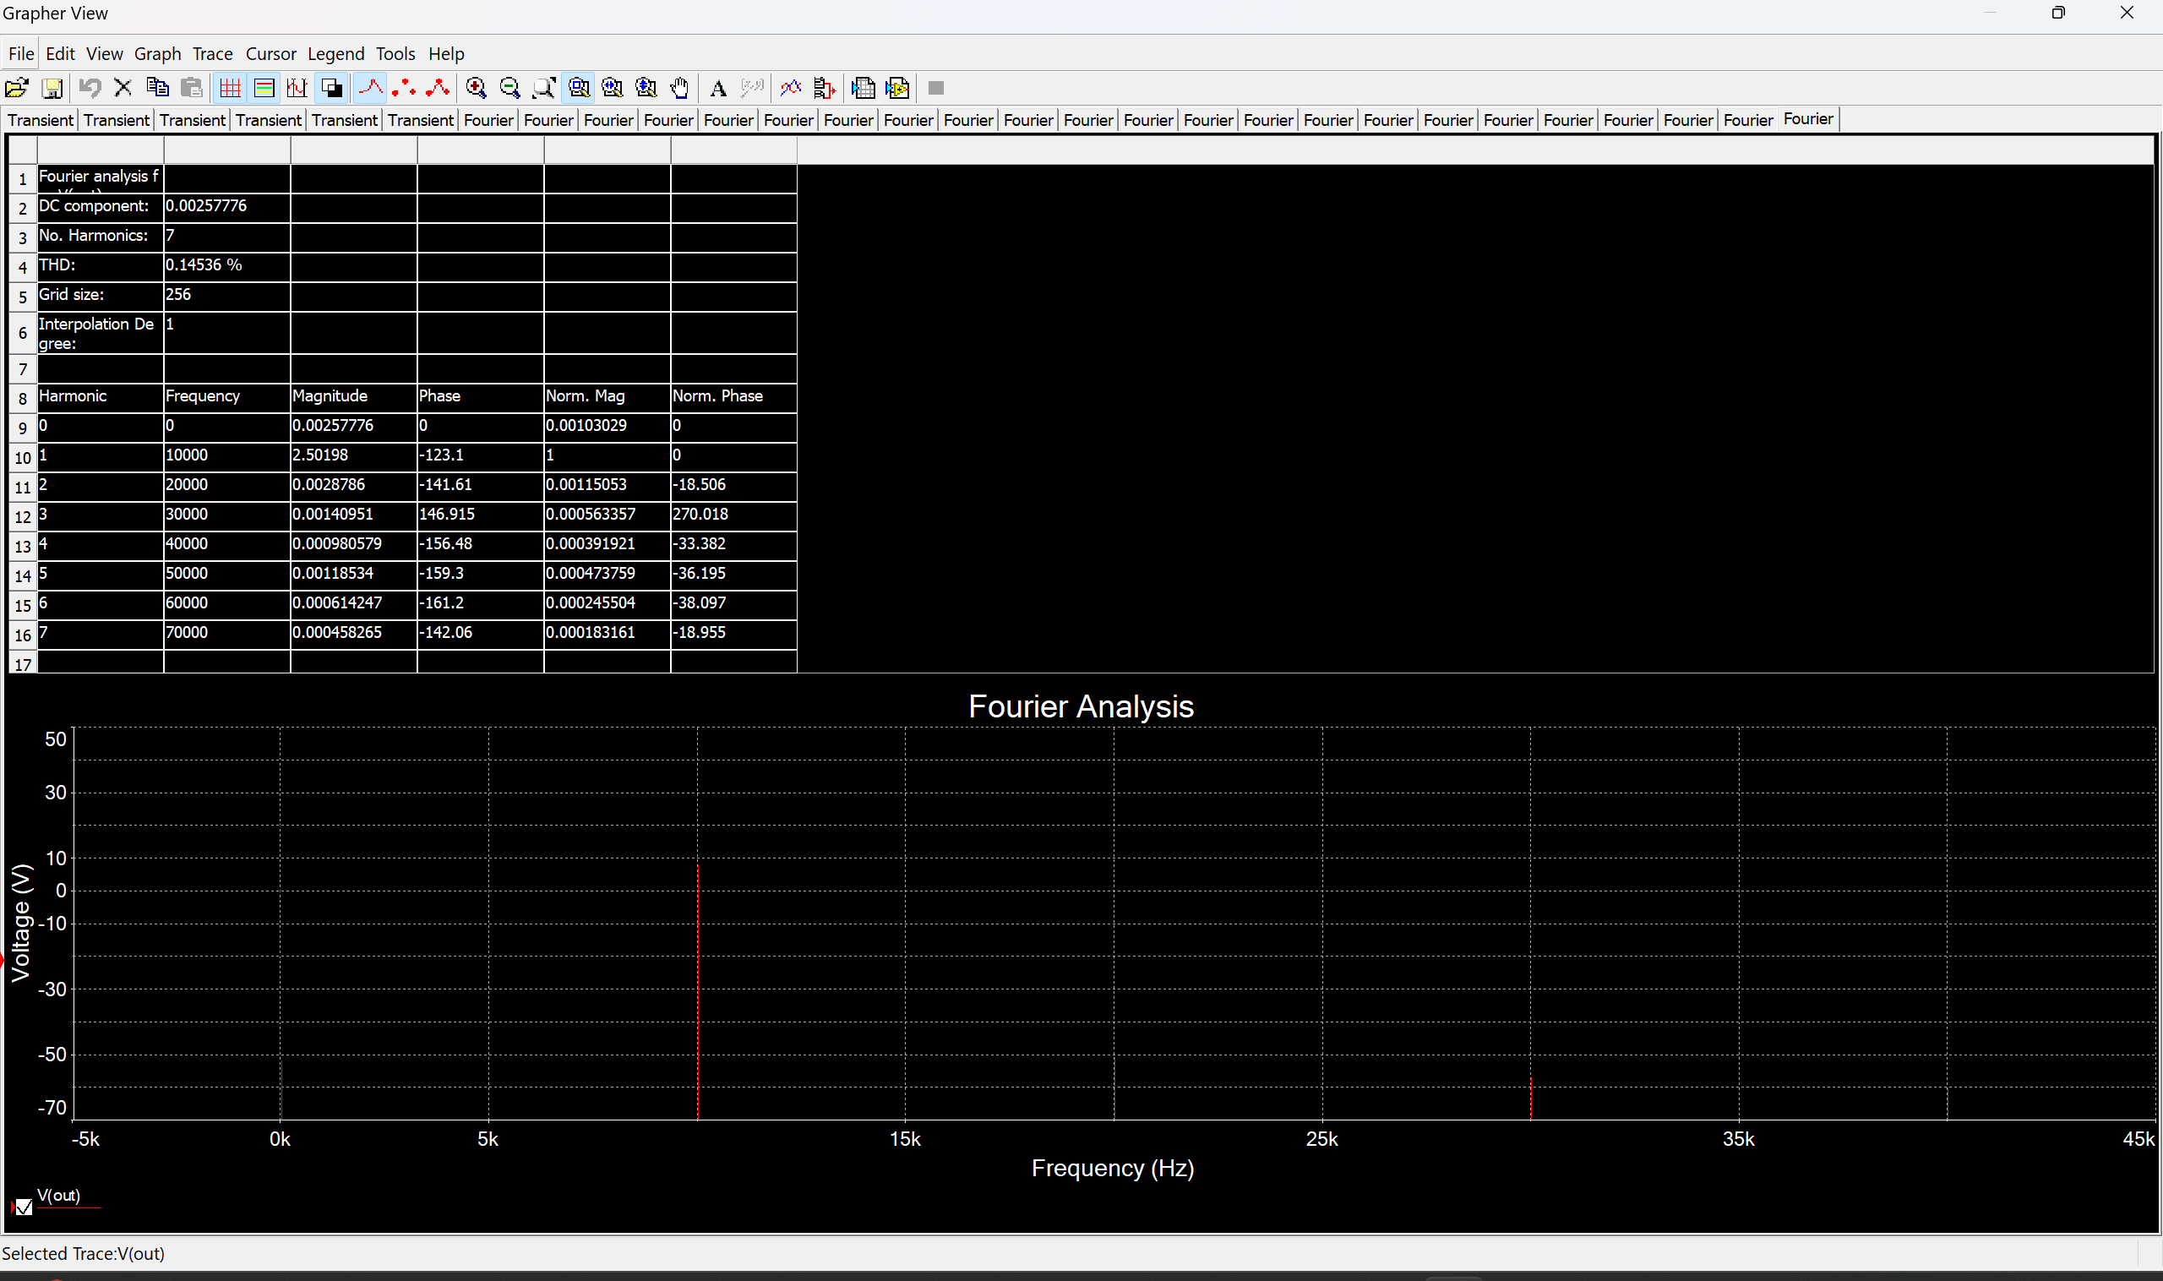

Approach
Firstly, I tried Wien Bridge, RC, Quadrature and Bubba oscillators in Multisim. The one I was most satisfied with was the Quadrature, so I continued to build to test until I went in the lab. There I implemented the Quadrature with diode clipping, but was disappointed about the poor distortion. After many trial and error actions, adjusting the potentiometers I was able to obtain the right frequency within 1% tolerance and a decent SFDR. Later I documented about lowering the distortion. I first looked at the clipping stage and I replaced the resistors with components having 30 times more resistance. I explained previously why. This small change reduced the current through that stage and helped me get a better distortion. Furthermore, I planed on replacing the diodes with either JFETs or light bulbs, but I faced logistical problems. I gave away that thought and I implemented a passband filter at the output of the oscillator. I got acceptable results, but after I read more in the book Horowitz, Paul and Hill, Winfield, The Art of Electronics, Cambridge University Press, 2015, I realized an active filter is offering better selectivity. I implemented it, thus obtaining a significantly better distortion. Throughout all of these stages I had hardships adjusting the potentiometers in order to obtain the right frequency, but I eventually was able to finish it properly.
During the process I had to do a lot of debugging because I wouldn’t have an oscillation, or it would oscillate at 8Mhz. After a session of debugging I realized that the breadboard I was using was constructed a bit different than any I have ever used in the past: the power rails had a gap at the halfway. This realization shocked me. Basically, my last op-amp was not even powered. After I wired together the two halves, the output came up as expected. Next time I design an oscillator, I will definitely physically implement the circuit stage by stage. After each stage, I would thoroughly test the functionality, and only after I’m satisfied with it, will I build the next stage. This I think is the most important lesson I’ve learned.

Performance
To assess the performance of the oscillator, the Spurious-free dynamic range (SFDR) metric was used. SFDR is defined as the ratio between the amplitude of the fundamental component and the amplitude of the strongest spurious component at the output.
Below, I uploaded photos of the oscilloscope screen performing FFT Magnitude Analyses for amplitudes ranging from 5 V down to 0.5 V, in steps of 0.5 V.
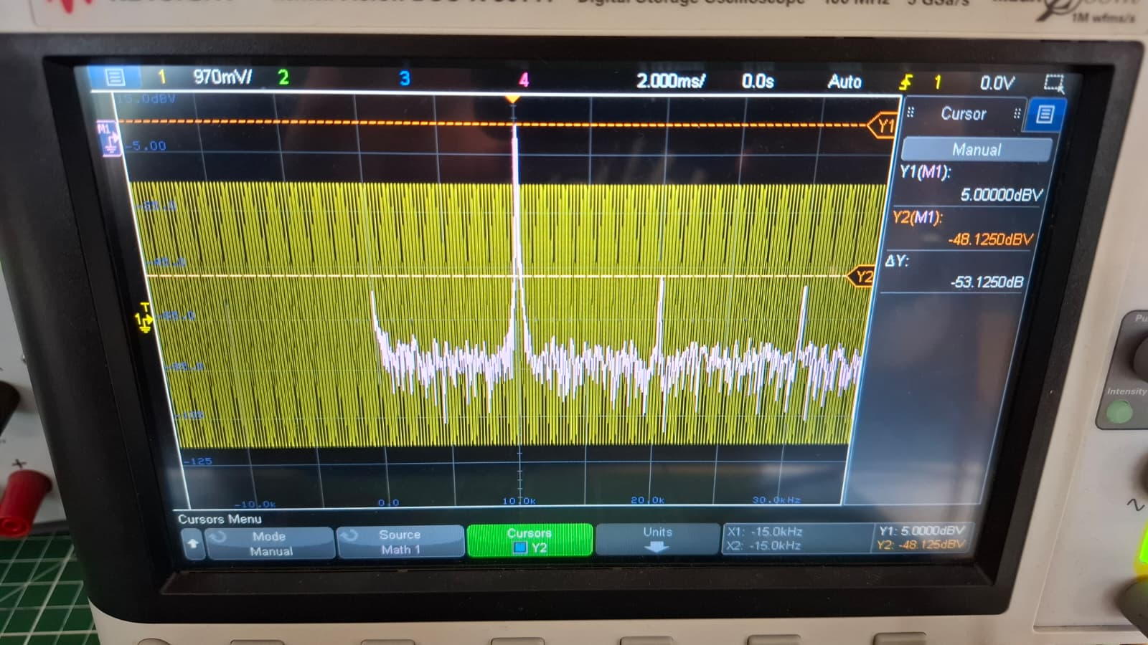
5Vpp SFDR=53.1dB

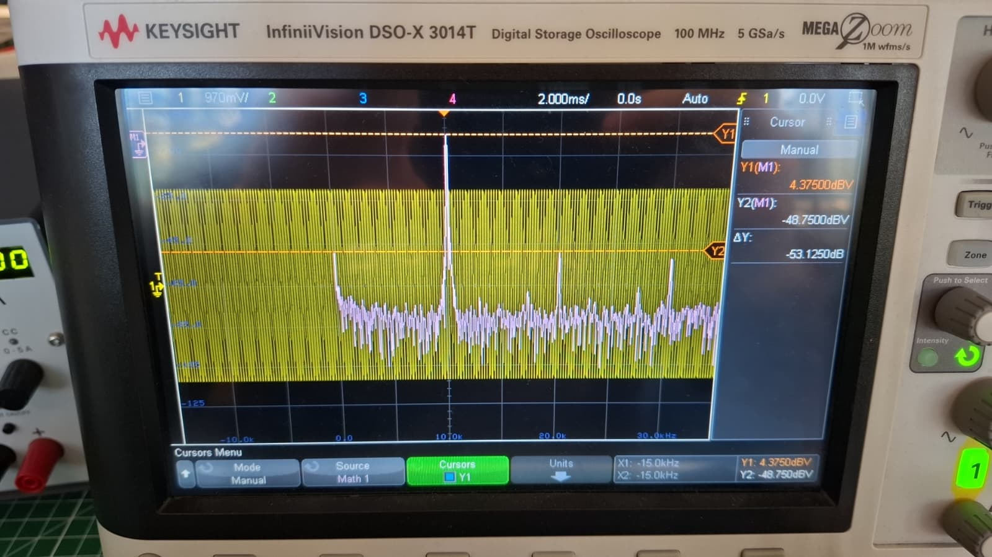
4.5Vpp

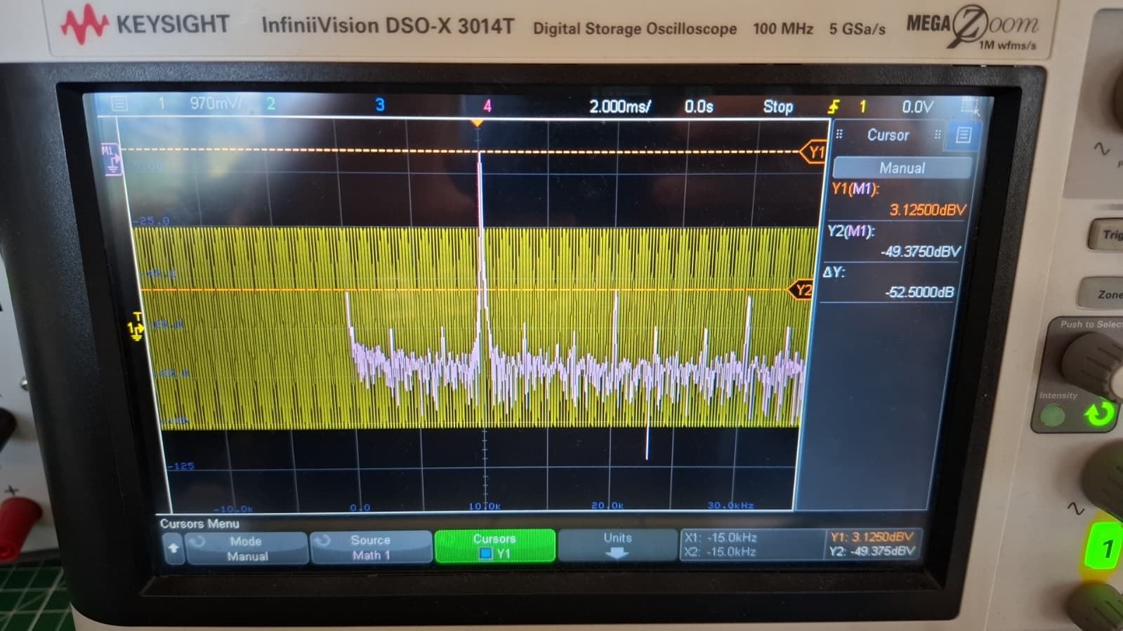
4Vpp

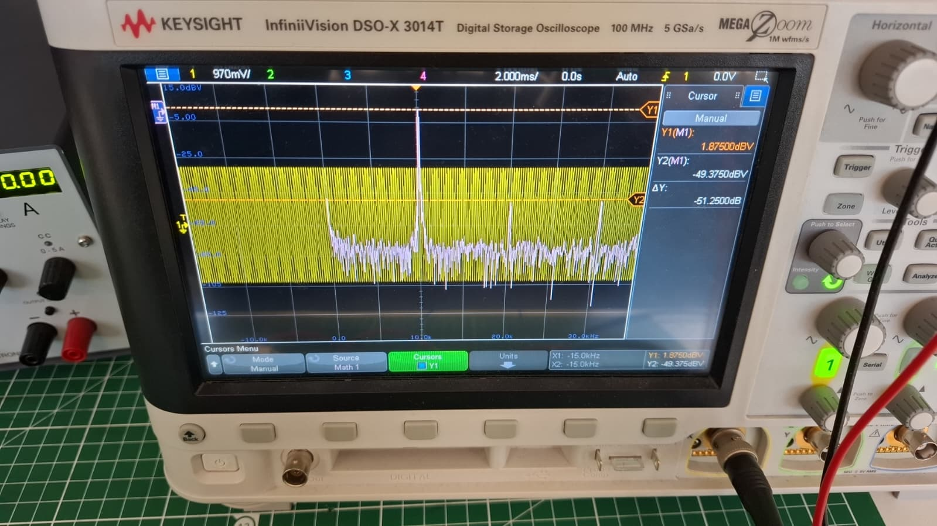
3.5Vpp

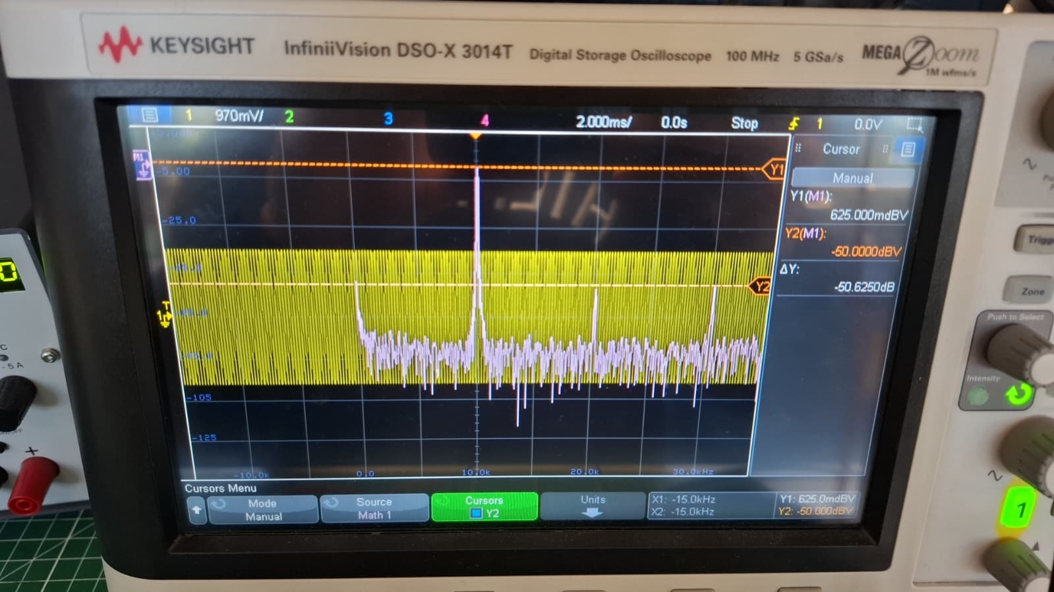
3Vpp

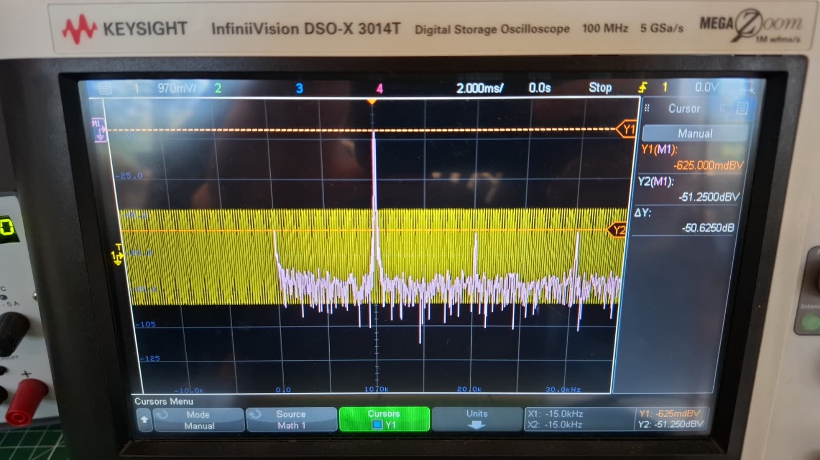
2.5Vpp

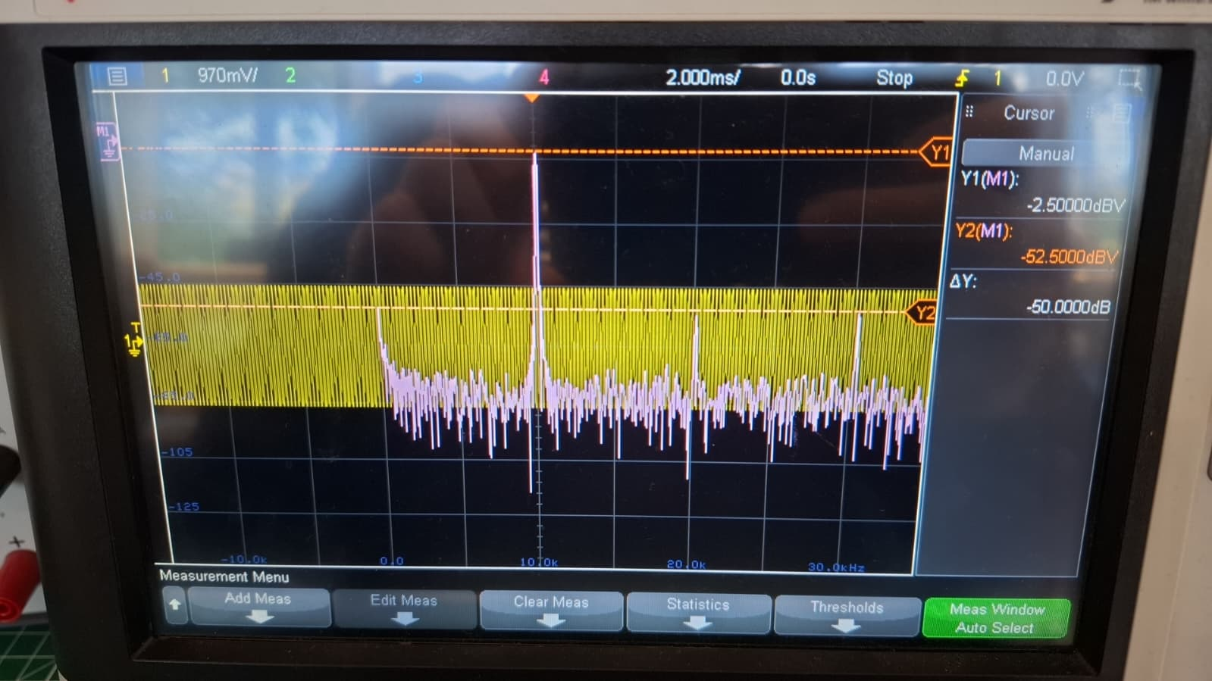
2Vpp

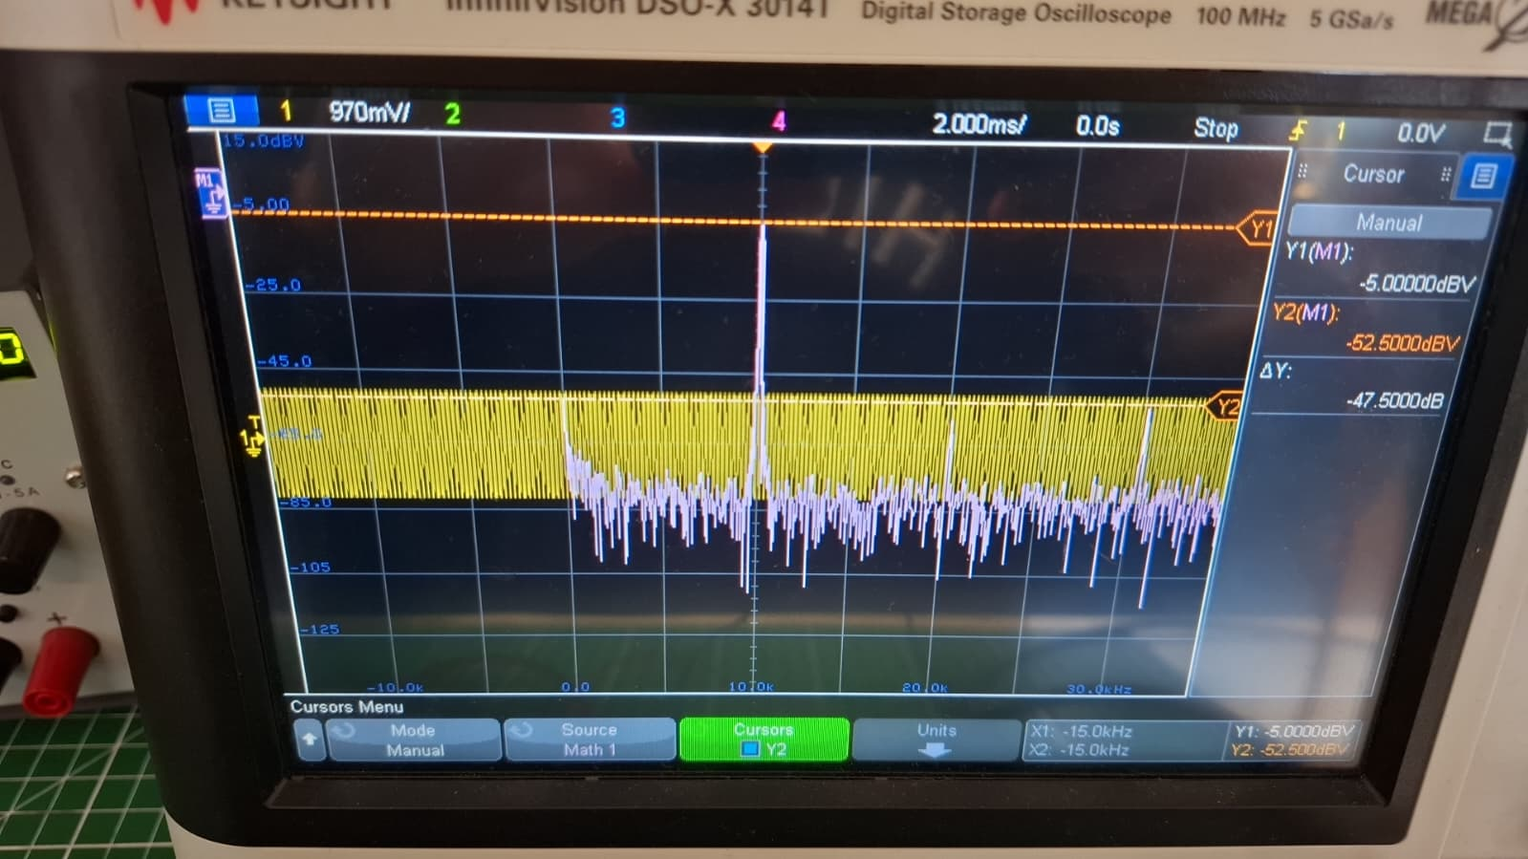
1.5Vpp

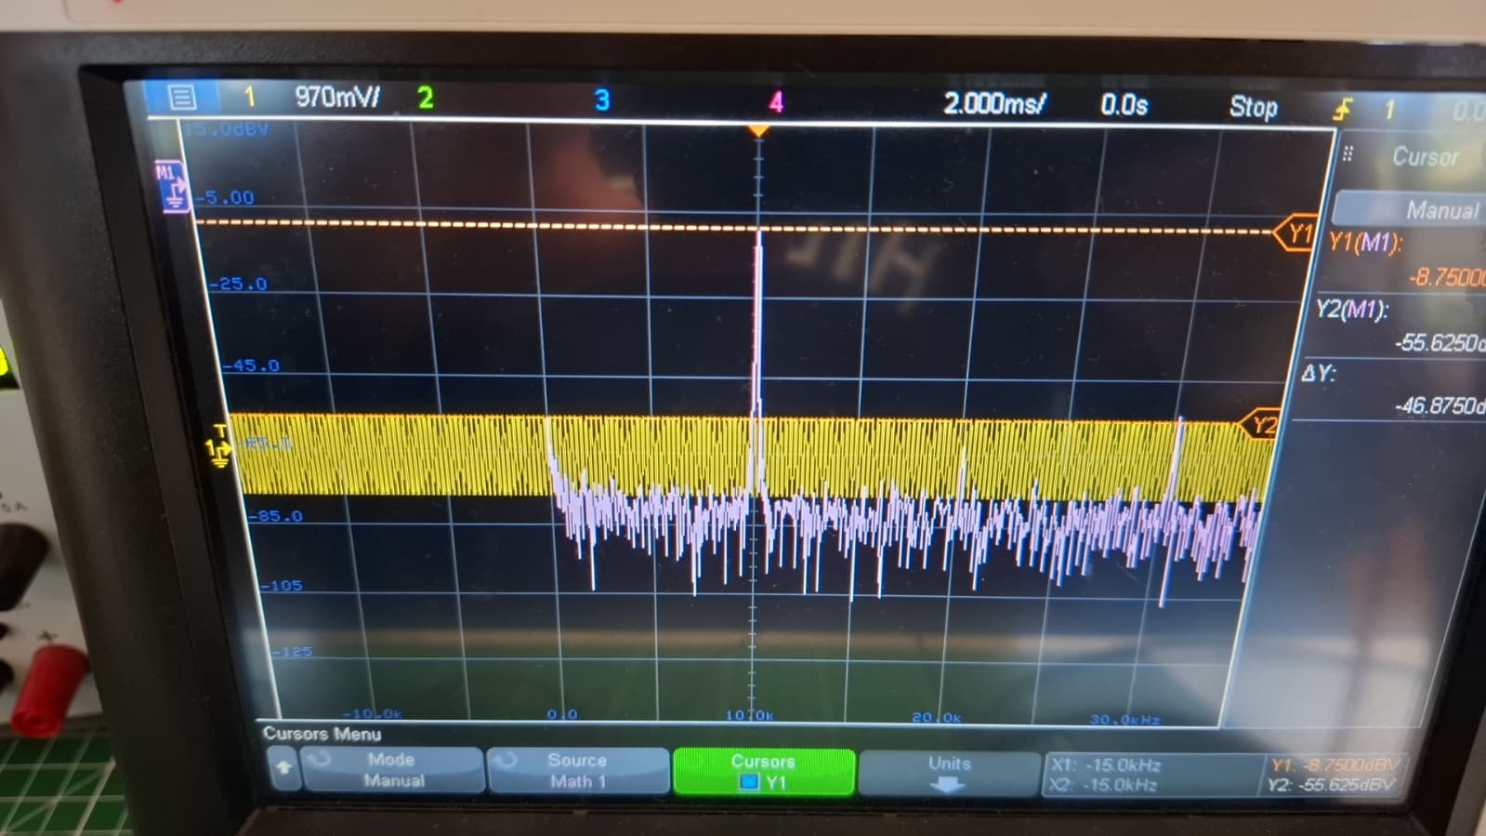
1Vpp

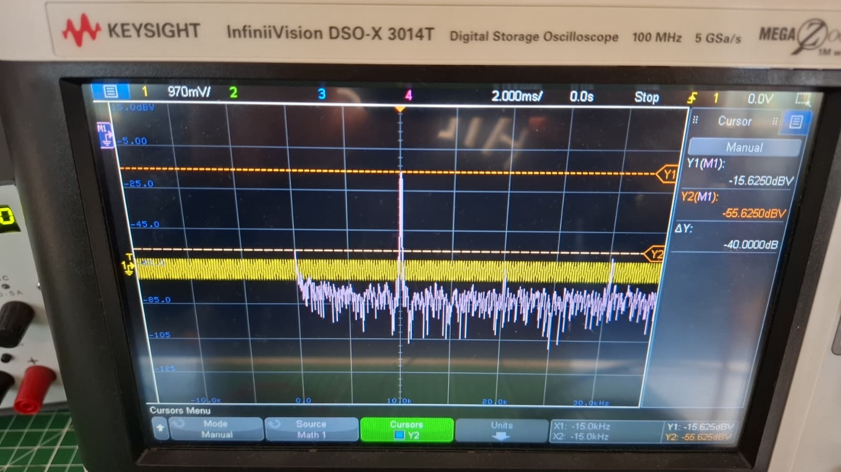
0.5Vpp

Conclusions
The key takeaway from this project is that practical circuit design is a trade-off between theoretical ideals and real-world constraints. The first lesson is that while the Wien Bridge oscillator offers theoretical simplicity, its extreme sensitivity to resistor and capacitor tolerances makes the Quadrature Oscillator a far more robust and practical choice for stable breadboard implementation. The second important message is that low-distortion design often requires sacrificing component simplicity, as evidenced by the necessary compromise of using a basic diode clipper, instead of a light bulb or JFET, thus retaining a worse SFDR. The third lesson is the importance of a multi-stage approach: the subsequent active bandpass filter proved essential, demonstrating that filtering is often a more reliable path to clean output than trying to reach perfection with fine adjustments in the potentiometers.
My work is special because it successfully integrates two theoretically distinct and non-imperfect stages and then employs an active bandpass filter to synthesize a high-quality sinusoidal wave despite the limitations imposed by component availability. This process demonstrates that effective engineering is often about managing imperfections, rather than achieving theoretical perfection. The final achievement was proving that the active filter's gain and sharp selectivity could overcome the intrinsic distortion of the chosen, readily available components, delivering a clean output suitable for the assignment's goal.
After all, the most important message is that engineering is the art of optimization under severe constraints.

